AM000-Asia-Japan-Mirror-Yellow Dragon-Zodiac-

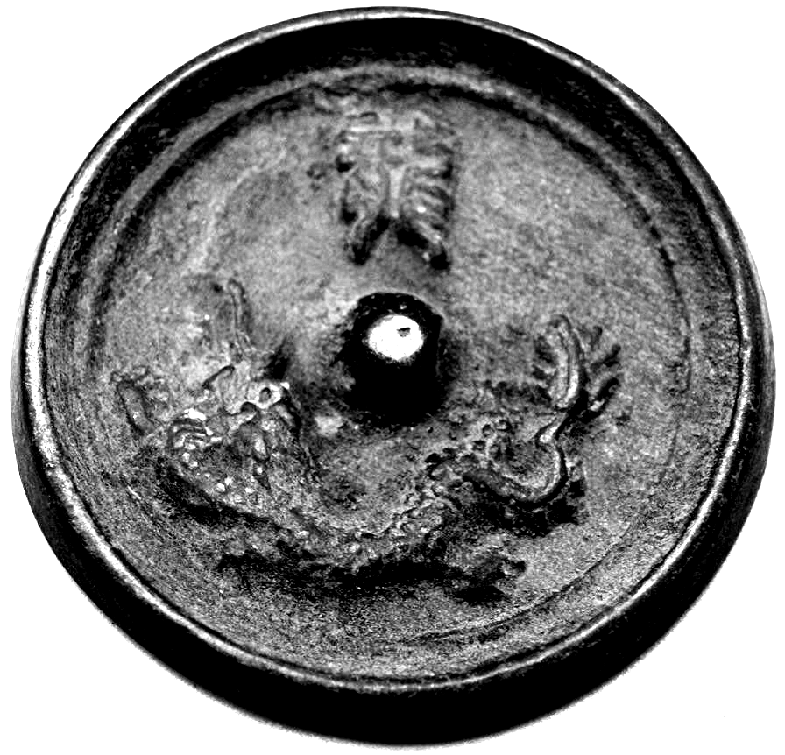

Stunning bronze Japanese mirror measuring 4.5cm x 4.5cm.  This bronze mirror has a lovely verdigris patina.  The back is decorated with a scene showing a dragon, one of the twelve zodiac animals.  It has a central boss which originally would have been pierced to allow a cord to be passed through for holding, this is now clogged due to the items age. The other side is undecorated and would have originally been polished to create a reflective surface.